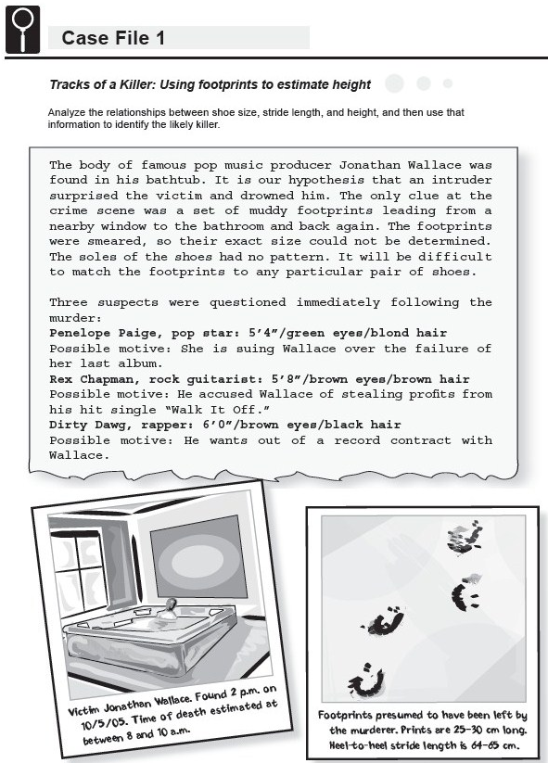
Tracks of a Killer

Question: Which suspect left the set of muddy footprints?
Knowledge Probe: Are there any anatomical relationships in humans that you know of? For example, how does arm span relate to height?
Prediction: Based solely on the information given, which suspect do you think could have left the muddy footprint?
Investigation Plan:
1. Measurement 1: Use the tape measure or meter stick to measure each person’s height without shoes in inches. Record the data in your notebook.
2. Measurement 2: Have each person remove his or her right shoe. Turn the shoe over and use a ruler to measure the distance from the tip of the toe to the end of the heel. Record the length of the person’s shoe in inches.
3. Measurement 3: Mark a starting line with chalk or tape. Have each person stand with the backs of his or her heels at the edge of the starting line. Starting at this point, each person should take 10 normal-length walking steps in a straight line. After the 10th step, the person should stop and bring his or her heels together. Mark the final position of the back of the person's heels, and measure the distance, in inches, between that mark and the edge of the starting line. Calculate the average stride length by dividing this distance by 10. Record each person's average stride length in inches.
4. When all of the data are collected, compile a complete record for all individuals in the class by adding your group’s data to the class spreadsheet.
Data Analysis:
Create 2 graphs, one comparing shoe length to height and one comparing stride length to height.
- Graph #1: Using Microsoft Excel, create two columns, one for shoe length, one for height.
- Type in or copy and paste the class data.
- Highlight the two columns, and go to “Insert”, “Scatter”.
- Choose the chart layout that allows you to type in labels for the title and both the x- and y-axis. Add and appropriate title and labels.
- Highlight the data points. Right click on the data points and choose “Add Trendline”.
- A box should pop up that says “Format Trendline”. Check the boxes that say “Show equation on chart” and “Show r-squared value on chart”.
- Repeat steps a-f for Graph #2.
The correlation (r²) value tells you how well the line fits the data. The closer the value is to 1, the better the line fits the data.
Once you have created each graph, and determined the r² value, answer the questions below:
- Based on your data, is there a linear relationship between height and shoe length? Is there a linear relationship between height and stride length? Explain both answers.
- Do you think it is possible to infer a person’s height from his or her shoe size? Explain your answer.
Explanation:
Claim: Using the relationships that you calculated, determine which of the three suspects most likely left the footprints to and from Jonathan Wallace’s bathroom. Your claim should be a statement that answers the initial question.
Evidence: Show your calculations (Hint: in your equations, x = stride length and y = height or x = shoe length and y = height)
Reasoning: Explain why your evidence counts as evidence. What is the scientific principle behind it?
Evaluation: Using your QPOE₂ Model, write an appropriate evaluation for your investigation.
Application:
- Using the relationship between height and stride length you calculated, determine the approximate heights of people with the following stride lengths:
- 29.5 in.
- 22 in.
- 18 in.
- Suppose you measure the stride length of a set of footprints, and you predict that the person who made the footprints is 69 inches tall. Later, you find out that the person who made the footprints is only 60 inches tall. Give possible reasons why your prediction could have been incorrect (at least two).

