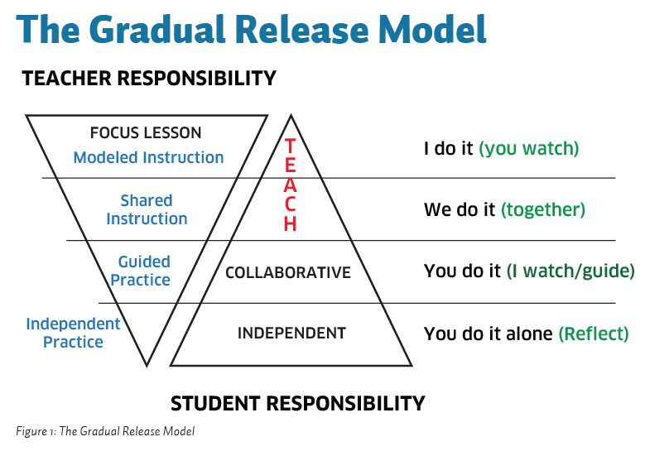
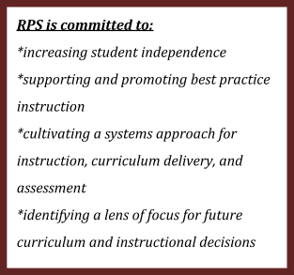
During the 2014-15 school year, RPS will begin the implementation of a Gradual Release of Responsibility common instructional framework. In addition to ensuring educational excellence for students, a common instructional model provides a framework to further align the school improvement process.
YEAR 1: Build Base Knowledge
- 2014-15 EXPOSE all staff to the research of the Gradual Release of Responsibility.
- EXPLAIN and DEFINE the components of GRR
- CREATE common vocabulary and understanding DK-12
- Purposeful incorporation of GRR in lessons
- Targeted goals for professional growth related to GRR
- PROVIDE targeted professional learning opportunities for all staff members

YEAR 2: Deepening and Applying Knowledge
- Professional Development opportunities through trainings and Learning Lab experiences
- Integration of GRR into school improvement processes, lesson planning, and evaluations
Our Vision For the Future
Students will know and communicate their learning targets
Students will observe teachers share their thinking as they approach a new or difficult task.
Students will collaborate with peers to synthesize, process, and apply new learning.
Students will demonstrate a metacognitive approach to learning.
