Review Sheet – Forensic Entomology Quiz
- What type of insect is usually first to colonize a corpse?
- What are the stages of blowfly development? Draw the lifecycle.
- Describe each stage of blowfly development? What distinguishes them from each other?
- What are the 5 stages of decomposition? What happens during each stage?
- What gases emitted by a corpse attract blowflies?
- What is cell autolysis?
- What causes a corpse to begin to bloat during putrefaction?
- What factors can affect decomposition? Do they make decomposition faster or slower?
- What factors can affect insect development?
- Use your dichotomous key to identify the fly species below:
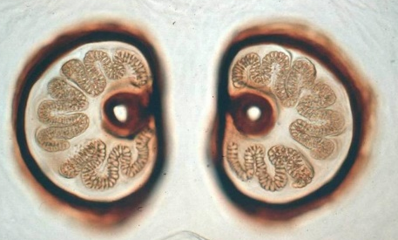

- What are accumulated degree hours? How are they calculated? How are they used to determine Post Mortem Interval?
- Be able to calculate PMI using accumulated degree hours. [see ADH Practice and Nature’s Witness examples]

Review Sheet – Forensic Entomology Quiz
- What type of insect is usually first to colonize a corpse?
- What are the stages of blowfly development? Draw the lifecycle.
- Describe each stage of blowfly development? What distinguishes them from each other?
- What are the 5 stages of decomposition? What happens during each stage?
- What gases emitted by a corpse attract blowflies?
- What is cell autolysis?
- What causes a corpse to begin to bloat during putrefaction?
- What factors can affect decomposition? Do they make decomposition faster or slower?
- What factors can affect insect development?
- Use your dichotomous key to identify the fly species below:

- What are accumulated degree hours? How are they calculated? How are they used to determine Post Mortem Interval?
- Be able to calculate PMI using accumulated degree hours. [see ADH Practice and Nature’s Witness examples]

