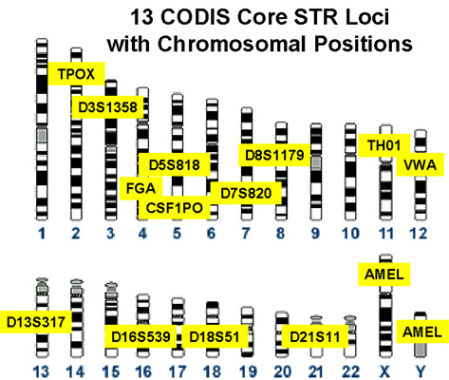
Reading DNA Profiles
There are three standard profiles that are used to look at DNA profiles. They each look at different parts of the human DNA. There are three color groups blue, green and yellow. There are two different primer sets that are used. The primers are the small pieces of DNA used to start the replication process of the part of the DNA to be tested. The Profiler Plus uses three primers for blue, three primers plus sex chromosomes for green and three primers for yellow. The Cofiler uses two primers for blue (one is different from Profiler), three primers plus the sex chromosomes for the green and one for yellow, which is the same as one for the Profiler. This makes a total of thirteen loci that can be looked at, as shown in the diagram to the right. Each person inherits two alleles in each of these loci so a profile looks at a total of twenty-six alleles.

When you learned genetics you used letters to represent alleles. In DNA profiles numbers are used to represent alleles. The numbers represent the number of short tandem repeats (STR’s) found at each locus. A person inherits their STR’s from their parents getting one chromosome from mom and one chromosome from dad. Based on this the DNA profile can be used to determine parent/child relationships as in paternity testing.

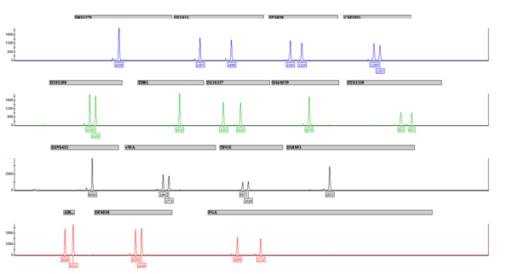
A complete DNA profile example is shown below.

Using DNA samples from felons and volunteers, frequencies of alleles have been calculated. Based on this the probability of two people having the same genotypes can be calculated. These calculations follow the Hardy-Weinberg equilibrium equation, p² + 2pq + q² = 1. For example, the person below is heterozygous for vWA and has the 14 and 16 alleles. The frequency of the 14 allele is 0.102 and the frequency of the 16 allele is 0.218. Because this is heterozygous, we will use the 2pq part of the equation. So the frequency of having both of these alleles is 2(.102)(.218) = 0.0445.

For individuals that are homozygotes, only one peak will appear. The individual below is homozygous 8,8 for TPOX, meaning that he has two 8 alleles. The frequency of the 8 allele is 0.728. Because it is homozygous, we will use the p² part of the equation. So the frequency of having both 8 alleles is (0.728)² = 0.529.

Procedure
Part 1: Writing Genotypes
Determine the genotype of the profiles in the lab manual and write it in 1 and 2 below. Genotypes should be written as 2 numbers separated by a comma.
Examples: 12,16 or 7,7

Data and Conclusions
- Profile of Person 1:

Blue = ____________________________________________

Green = ____________________________________________

Black = ____________________________________________

Red = ______________________________________________

- Profile of Person 2:

Blue = ____________________________________________

Green = ____________________________________________

Black = ____________________________________________

Part 2: The Smith Family

- Fill in the empty spaces by looking at the children of Mr. and Mrs. Smith. Remember that children receive one allele from each parent. Also remember that one peak means that the person has two of that allele. For example, Mrs. Smith would have two 19 alleles for D3.

Person | D3 | VWA | FGA | AMEL | D8
Mr. Smith |  |  |  | X,Y
Mrs. Smith | 19 | 10, 12 | 19, 22 | X | 12, 19
Joey Smith | 12, 19 | 10,13 | 22,29 | X,Y | 19
Amelia Smith | 18, 19 | 12, 13 | 19, 24 | X | 13, 19
Stefani Smith | 18,19 | 10,13 | 19, 29 | X | 12, 19

- Explain why you gave Mr. Smith the alleles that you did?

- Based on the information above could a man with the following genotype be Mr. Smith’s son from another marriage? Explain why or why not.
D3 – 12 VWA – 13, 14 FGA – 24, 30 AMEL - X,Y D8 – 10, 19

Part 3: Allele Frequencies

Allele Frequencies
D3 vWA FGA
Allele Freq. Allele Freq. Allele Freq.
13 .011 14 .102 18 .017
14 .089 15 .128 19 .067
15 .299 16 .218 20 .145
16 .246 17 .251 21 .187
17 .207 18 .226 22 .182
18 .137 19 .067 23 .156
20 .011 24 .120
25 .064
26 .036
27 .010
28 .010

- Using the allele frequencies above, calculate the frequency of a person with the following peaks on a DNA Profile:

D3 17, 18
VWA 16
FGA 21, 25

- Using the allele frequencies above, calculate the frequency of a person with the following peaks on a DNArofile:

D3 13,14
VWA 18,19
FGA 23

- Use the following information to calculate the frequency of the father being a match to the child. First, determine which alleles the father must have passed on to the child. Next, determine the frequency of each of those alleles. Finally, multiply each of the frequencies together.

Locus Mom Child Alleged Father
D3 12, 13 12, 16 16, 19
VWA 16, 18 18, 21 18
FGA 19, 21 21, 26 26, 30

