Chapter 7 DNA Fingerprinting Reading Assignment Name: Hour:
Read pages 158-171. Complete the following activities/questions as you read. Type in your answers in the blank spaces provided. Please extend on to the second page instead of decreasing the font. 15 points
- DNA’s structure is a double helix, similar to a twisted ladder. The blue “sides” of the ladder in the picture to the right are composed of what two molecules? (2 points)

- The colored “rungs” of the ladder in the picture to the right are called what? (1 points)

- How do genes and alleles differ? (1 points)

- What are VNTRs and STRs? (2 points)

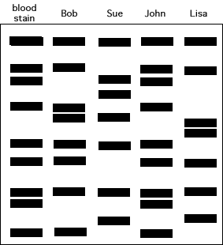
- What are the two main purposes of DNA fingerprinting (profiling)? (2 points)

- Does the blood stain match Bob, Sue, John, or Lisa? Explain. (2 points)

- Of the two purposes you listed in #5, which is #6 an example of? (1 point)
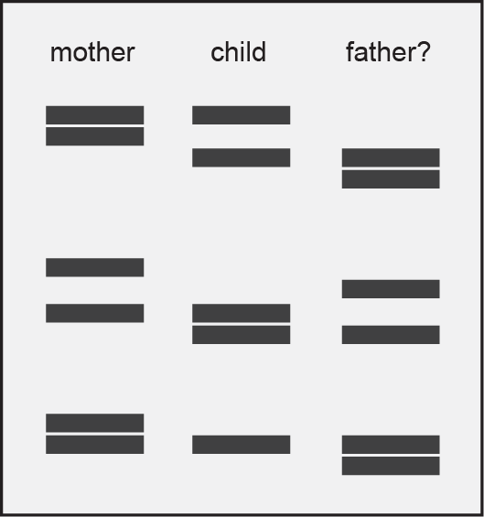
- a. In the picture to the right, did the child inherit all of the genes from either his mother or father? Explain. (2 points)

- Is this the biological child of these two parents? Explain. (2 points)

