Forensic Science Review Sheet – Chapter 15 Impressions
- Describe the differences between latent, patent, and plastic impressions. Give examples of each.
- What are some characteristics of shoe impressions and what is their significance (what information can these characteristics give about the person that made them?)
- Explain the difference between class and individual evidence.
- How are latent prints collected?
- How are plastic prints collected?
- What are track width, wheelbase, and turning diameter? How are each measured?
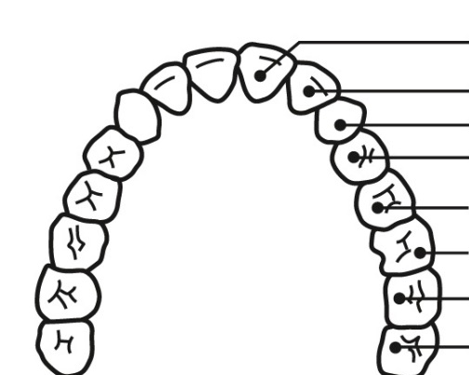
- Label each tooth with the appropriate name.

- How can a person’s teeth be used to approximate their age?
- On the diagram to the right, label the enamel, dentin, pulp, gum, cementum, bone, blood vessels, and nerves.

- Use the graph and equation below to calculate:
  - the approximate shoe length of a person who is 75.5 inches tall
  - the approximate height of someone with a shoe length of 12.1 inches

