Bones Quiz Review

1. What is anthropology?
2. What is an osteobiography?
3. What is ossification?
4. What is an epiphysis line?
5. How does a woman’s skull differ from a male’s skull?
6. How does a woman’s pelvis differ from a man’s?
7. How many bones does a baby have? How many does an adult have? Why?
8. How can age be determined using the skull and long bones?
9. What parts of the skeleton are used to determine race?
10. What type of DNA is most commonly found in bone?
11. A femur found to be 35 cm and humerus found to be 27 cm. They are both estimated to be from a Caucasian female. Use the chart below to calculate the height of the person based on each long bone. Based on the heights, do you believe these bones are from the same person? Explain.



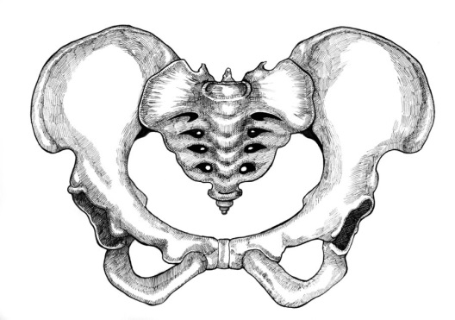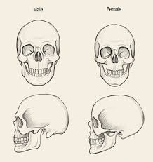

1. Is the skull to the right from a male or female?
2. Is the pelvis to the right from a male or female?

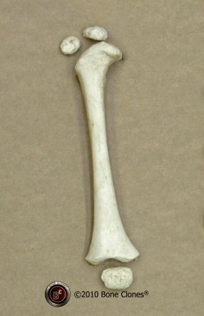

1. Is the bone to the right from a child or an adult?