Chapter 15 Casts and Impressions Reading Assignment Name: Hour:
Read pages 430-445. Complete the following activities/questions as you read. Type in your answers in the blank spaces provided. Please extend on to the second page instead of decreasing the font. 15 points
- What kind of information can an investigator get from a person’s shoe print? Name at least six pieces of information. (3 points)

- Complete the table below. (4 points)
Shoe Impression Lifting Method | Type of Impression For Method (Latent, Patent, or Plastic) | Description of Method
Dental Stone Cast
Electrostatic Dusting and Lifting
Gel Lifting
Plaster of Paris Cast
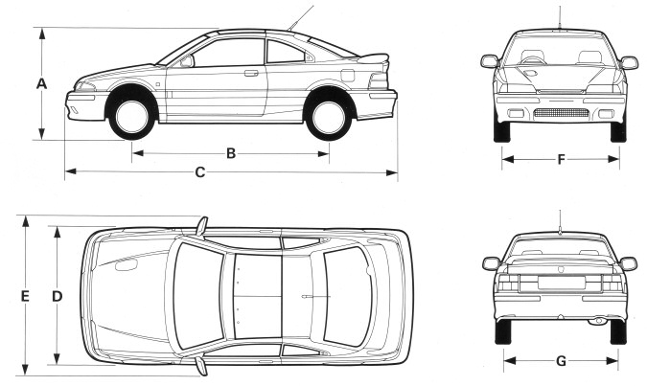
- In the picture to the right, which letter or letters represent the: (2 points)
  - Wheelbase? ____________________
  - Track width? ____________________
- According to Figure 15-13 on pages 439 and 440, which vehicle listed has the: (3 points)
  - Largest wheelbase?
  - Largest turning diameter?
  - Largest tire size?
- What is a dentition pattern? What makes each one unique? (3 points)

