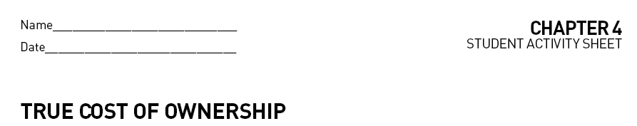
How much value do you lose on the purchase of a new automobile? Is it the same for each one? Find out how much you will lose in a five-year cycle. Choose a new car to research. Go to edmunds.com, click on the new car menu and select True Cost to Own.
In an Excel Spreadsheet record the costs for 5-year total of the following categories:
Depreciation
Taxes & Fees
Financing
Fuel
Insurance
Maintenance
Repairs
Tax Credit (if applicable)
Total
Next, get the information on the same make of a two-year older model. Add the information to the spreadsheet. Make a chart comparing the two cars.
Answer the following questions in the spreadsheet.
How much could you save by buying the two-year-old model?
What is your savings expressed in percentage for each category? (This can be answered in a new column of the information above)
In which categories do you see the greatest loss?
Why isn’t there much change in the other categories? What does that tell you about the older model?

Submit your spreadsheet for grading.

