Chapter 13 Forensic Anthropology Name: Hour:
Read pages 360-375. Complete the following activities/questions as you read. Type in your answers in the blank spaces provided. Please extend on to the second page instead of decreasing the font. 15 points
- Label the following as an osteoblast, osteoclast, or osteocyte. (3 points)
  - _____________________________Mature bone cells; form the bone framework
  - _____________________________Cells that secrete matrix for bone formation
  - _____________________________Cells that dissolves bone during growth and healing

- Give 5 examples of types of information bones can tell us. (5 points)

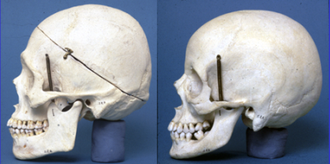
- Using Figure 13-10 and 13-11, label each of the skulls below as “male” or “female”. (2)

- Determine at least how old each person is based on the descriptions below (3 points):
  - Pubis and ischium are almost completely united _______________
  - Coronal suture is closed __________________
  - Femur head is fused to the shaft __________________

- Describe 2 ways in which facial reconstruction is done today (2 points).

